Abstract Submission Preparation Manual
Before you submit your abstract online, please work through this manual to make sure you have all information ready!

1. General Information
Abstract submission for MSToronto2026 is open from March 24, 2026, until May 07, 2026.
The submission is free of charge and must be completed online only via the Abstract Submission platform.
Abstract Submission Deadline: Thursday, May 07, 2026, 23:59 EDT
2. Notifications:
Each abstract will be reviewed and rated by external blinded experts and final selection will be made by the Scientific Program Committee. Notification of acceptance or rejection of submitted abstracts and final presentation type will only be sent to the presenting author via email by late July 2026. The presenting author will have to inform his co-authors of the decision.
Full instructions concerning preparation and presentation will be sent to the presenting author in the notification letter and closer to the congress.
3. Publication:
Publication Embargo: MSToronto2026 has an embargo policy on all abstracts submitted to the conference. The embargo for the regular submitted abstracts will be lifted on October 7, 2026. The embargo for the Late Breaking abstracts will be lifted on October 21, 2026.
All accepted abstracts will be published in Multiple Sclerosis Journal (online supplement) and featured on the MSToronto2026 website, mobile app, and digital platform.
4. Guidelines
Find the Guidelines HERE
How to submit your abstract:
(to prepare skip step 1-3, come back once you are ready to submit)

STEP 1: Login to the MSToronto2026 Congress Platform
(MSToronto2026 - Home)
(If you encounter any issues with the log-in you can’t resolve, please contact us. Details on the end of the document)

STEP 2: Click on “Abstract Submission”
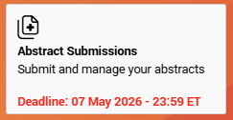

and then on “+Submit new abstract”

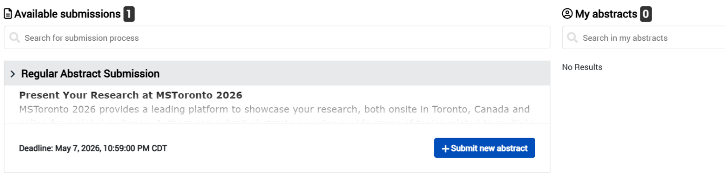
STEP 3: Read and follow the sequence of the sections.
Read the guidelines carefully
Read and click to continue.

STEP 4: Fill out all submission steps
1. Please type your abstract title into the box below in sentence case (not in capital or lower-case letters only)
Title
Click or tap here to enter text.
2. Select your preferred presentation type. Be aware that the final format of presentation will be decided on by the review board based on the quality of abstracts submitted.
Presentation Type
Choose an item.
3. Carefully select the topic and subtopic under which you wish to submit your abstract for review.
Topic
Choose an item.
Subtopic
- Clinical Aspects of MS | Choose an item.
- Pathology and Pathogenesis of MS | Choose an item.
- Imaging and Non-imaging Biomarkers | Choose an item.
- Therapy | Choose an item.
Complete and click to continue.

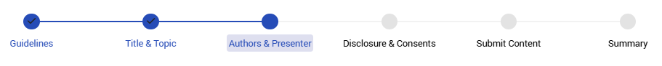
PRESENTERS & CO-AUTHORS
Prepare a list with all authors (full name, no caps!), their e-mail address, institution, city, gender and affiliation(s)
You may enter up to 40 authors, including the Presenting Author.
You may enter up to 40 authors in the list, including the Presenter of the abstract.
- Click "Add author" then provide the email address of the author and "Validate" to proceed
- Enter the mandatory fields (*) then select "Add" (if the author has a profile, the field will be pre-filled)

Once you have added an author, select "Edit details".
- Go to "Affiliation" and fill in information
- Click "Back to author list"

When all the authors are listed, click "Edit details" next to the person you will designate as "Presenting author".
- Go to "Role of the author"
- Select "Presenting author" and click "Done"

The button "Save and next" will be active only when you have selected the Presenting author.
IMPORTANT NOTE
- The presenting author of an accepted abstract must register and attend the congress to ensure the publication of abstracts.
- Submission of an abstract acknowledges your acceptance for the abstract to be published in the official conference publications.
- The submitting author is required to ensure that all co-authors are aware of the content of the abstract and agree to its submission, before submitting the abstract.
- Abstracts that have been previously presented at another international meeting cannot be submitted.
Complete and click to continue.
Funding Source
Source(s) of research funding or study support must be identified in this step. Write a short text, what kind of funding or support was provided. Make a statement for each co-author, use n/a where needed.
Source:
Click or tap here to enter text.

Confirmation/Consent
I confirm that I previewed this abstract and that all information are correct. I accept that the content of this abstract cannot be modified or corrected after the submission deadline and I am aware that it will be published exactly as submitted.
☐ I confirm
Submission of the abstract constitutes my consent to publication on the congress website, in the online program, on the digital congress platform and scientific journal. All authors have been informed about the publication and agree to publish this abstract submitted.
☐ I confirm
I confirm that this abstract contains only original material neither published nor presented prior October 21, 2026.
☐ I confirm
I confirm that the contact details for the presenting author saved in this system are those of the corresponding author, who will be notified about the status of the abstract. The presenting author is responsible for informing the other authors about the status of the abstract.
☐ I confirm
Should my abstract be accepted: I give permission to MSToronto to share my contact details with media representatives requesting additional information about my abstract publication
Choose an item.

Study Group
Please enter the name of your study group in the text field (if applicable)
Important: Do not add (co-)authors, affiliations, or departments. Co-authors listed in this field will not appear in the author index. Example: PS-TEAM Study Group
Click or tap here to enter text.

Educational Grant - Young Investigator Award
Grant:
A limited number of grants are available for young scientists (35 or younger) or those with justified study interruptions (e.g., maternity, caregiving) whose abstracts are accepted for oral or poster presentation.
Educational grants are available to onsite participants only. Recipients will receive complimentary registration and travel support for MSToronto2026. Grant funds will be distributed after the conclusion of the meeting.
Award:
Several awards will recognize outstanding oral/poster presentations by Young Investigators. Winners will be selected by an onsite judging committee and announced during the Closing Session on Friday, October 23.
Application Requirement:
Upload a passport copy (showing date of birth) or certification of justified study interruption (e.g., maternity leave).
Accepted formats: BMP, GIF, JPG, PDF (max. 1 MB). Late or incomplete applications will not be considered.

Do you wish to apply for an Educational Grant or Young Investigator Award?
Choose an item.

- If yes is selected,
Please select which one you would like to apply for:
Choose an item.

Date of Birth of presenting author:
Click or tap here to enter text.
Prepare document to upload in the format: BMP, GIF, JPG or PDF (max. 1 MB)

- If yes, but I don’t… is selected,
Please select which one you would like to apply for:
Choose an item.

Please explain here why you would still like to apply, even if you do not directly meet the criteria specified in the guidelines:
The scientific committee will take your response into account when selecting the grants:
Click or tap here to enter text.

Additional Questions
Is the presenting author a past attendee of an ACTRIMS Resident Summit, Young Scientist Summit, or Early Career Clinician & Scientist Summit?
Choose an item.

- If yes is selected,
Please select:
- Choose an item.

Is your research output resulting from an ECTRIMS Winter/Summer School?
Choose an item.

- If yes is selected,
Please select:
- Choose an item.

Complete and click to continue.

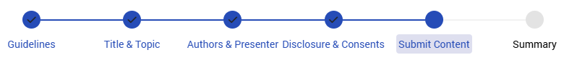

Overall Content Requirements

- Do a spell-check before entering your content – use American English

Characters: Maximum: 2550
Guidelines for preparation of abstracts: Click HERE
No image or table can be uploaded. Use the abstract submission site functions for formatting, Greek letters, mathematical symbols, special characters. Avoid complex mathematical formulae.
---
Background
Click or tap here to enter text.

Objectives/Aims
Click or tap here to enter text.

Methods
Click or tap here to enter text.

Results
Click or tap here to enter text.

Conclusions
Click or tap here to enter text.

STEP 5: Submit your abstract

In this section, you will get to preview your abstract body submitted.
Note: You can re-open your abstract to edit it until the deadline (Thursday, May 07, 2026, 23:59 EDT) but you have to RE-SUBMIT it again at the end or it will not be reviewed.
By submitting, you confirm the abstract is final and will be published as submitted.
A confirmation email will be sent to the submitter after successful submission.
--

Final approval of your submission
☐ Do you really want to submit your abstract with the entered information? After successful submission, you will receive confirmation by E-Mail.

Click on the “Submit” Button.

The submitter should receive a confirmation-email after successful submission.
If you did not receive this email or face submission issues during the process, please contact us:

abstracts.mstoronto@congrex.com
Monique Zimmermann - Abstract Coordinator
Phone direct: +41 61 686 77 27
Department: +41 61 686 77 99

